Sample Social Media Posts, Website or Email Content

Please feel free to use the sample copy below on your social media channels, website and email marketing. Please do link your audience back to our website.

SAMPLE COPY #1
We’re encouraging all CAI Chapter members, homeowner leaders and business partners to connect online with your local elected officials. CAI-CLAC has created a Legislative Toolkit to walk you through how. Download resources here: [link]

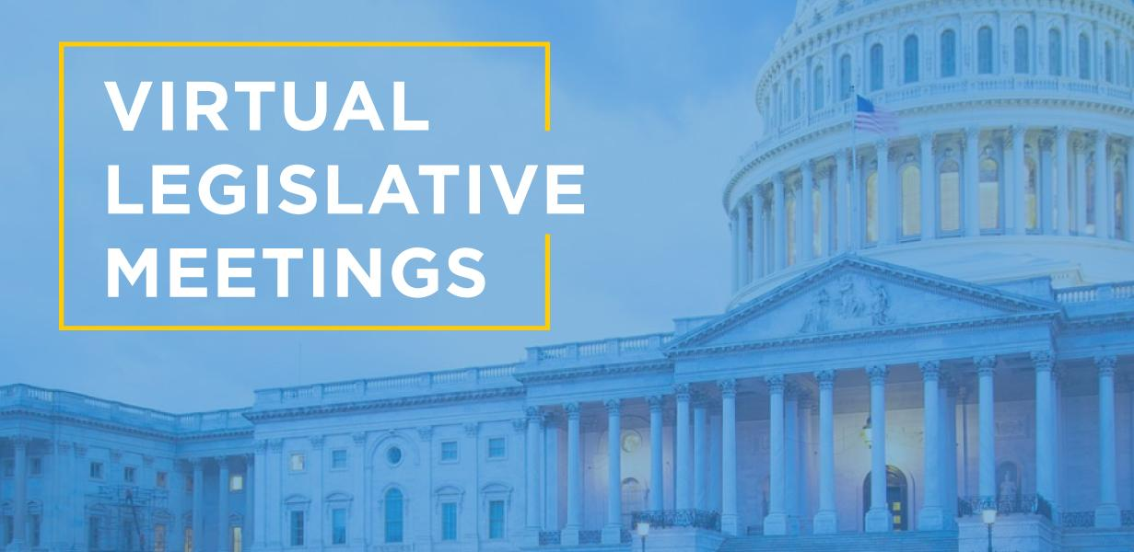

SAMPLE COPY #2
While many of us remain under shelter in place orders and California slowly reopens, we continue to stay connected to legislators virtually. Check out
CAI-CLAC’s Legislative Toolkit to learn how: [link]

SAMPLE COPY #3
Legislators still need to hear from constituents to know what’s working in community associations and your needs. Here 8 steps to effectively schedule a virtual online meeting with your legislator: [link]

SAMPLE COPY #4
Thank you for helping to keep legislators informed on the importance of community associations and your ability to self govern. View CAI-CLAC’s online Legislative Toolkit for everything you need to know: [link]

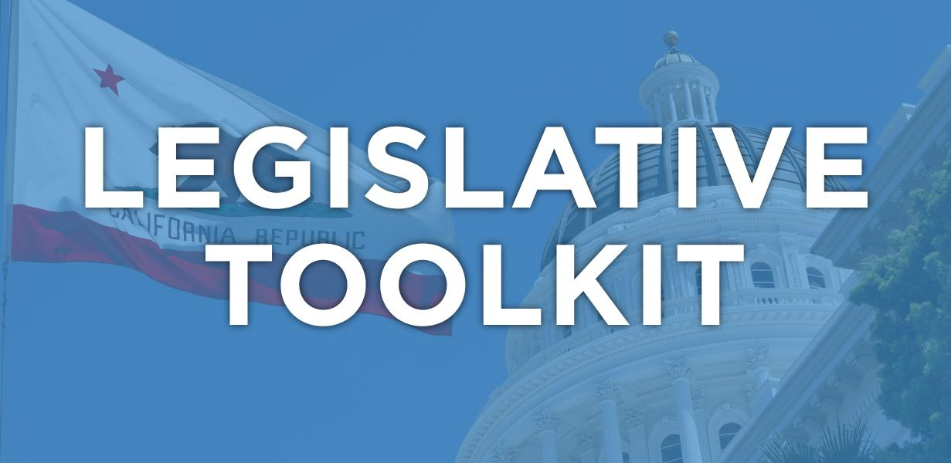

SAMPLE COPY #5
Several legislators are holding Facebook Live Town Halls and soliciting questions online. To connect with your local elected officials, click here: facebook.com/townhall.

